Open loop OPAMP Configuration:
In the case of amplifiers the term open loop indicates that no connection, exists between input and output terminals of any type. That is, the output signal is not feedback in any form as part of the input signal.
In open loop configuration, The OPAMP functions as a high gain amplifier. There are three open loop OPAMP configurations.
The Differential Amplifier:
Fig. 1, shows the open loop differential amplifier in which input signals v_{in1} and v_{in2} are applied to the positive and negative input terminals.
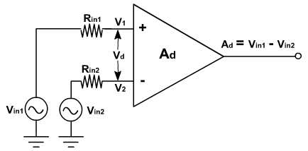
Fig. 1
Since the OPAMP amplifies the difference the between the two input signals, this configuration is called the differential amplifier. The OPAMP amplifies both ac and dc input signals. The source resistance R_{in1} and R_{in2} are normally negligible compared to the input resistance R_{i}. Therefore voltage drop across these resistances can be assumed to be zero.
Therefore
v₁ = v_{in1} and v₂ = v_{in2}.
v_{o} = A_{d} (v_{in1} – v_{in2} )
where, A_{d} is the open loop gain.
The Inverting Amplifier:
If the input is applied to only inverting terminal and non-inverting terminal is grounded then it is called inverting amplifier.This configuration is shown in fig. 2.
v₁= 0, v₂ = v_{in}.
v_{o} = -A_{d} v_{in}
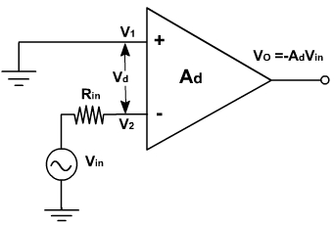
Fig. 2
The negative sign indicates that the output voltage is out of phase with respect to input 180 ° or is of opposite polarity. Thus the input signal is amplified and inverted also.
The non-inverting amplifier:
In this configuration, the input voltage is applied to non-inverting terminals and inverting terminal is ground as shown in fig. 3.
v₁ = +v_{in} v₂ = 0
v_{o} = +A_{d} v_{in}
This means that the input voltage is amplified by A_{d} and there is no phase reversal at the output.
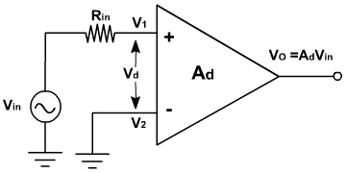
Fig. 3
In all there configurations any input signal slightly greater than zero drive the output to saturation level. This is because of very high gain. Thus when operated in open-loop, the output of the OPAMP is either negative or positive saturation or switches between positive and negative saturation levels. Therefore open loop op-amp is not used in linear applications.

